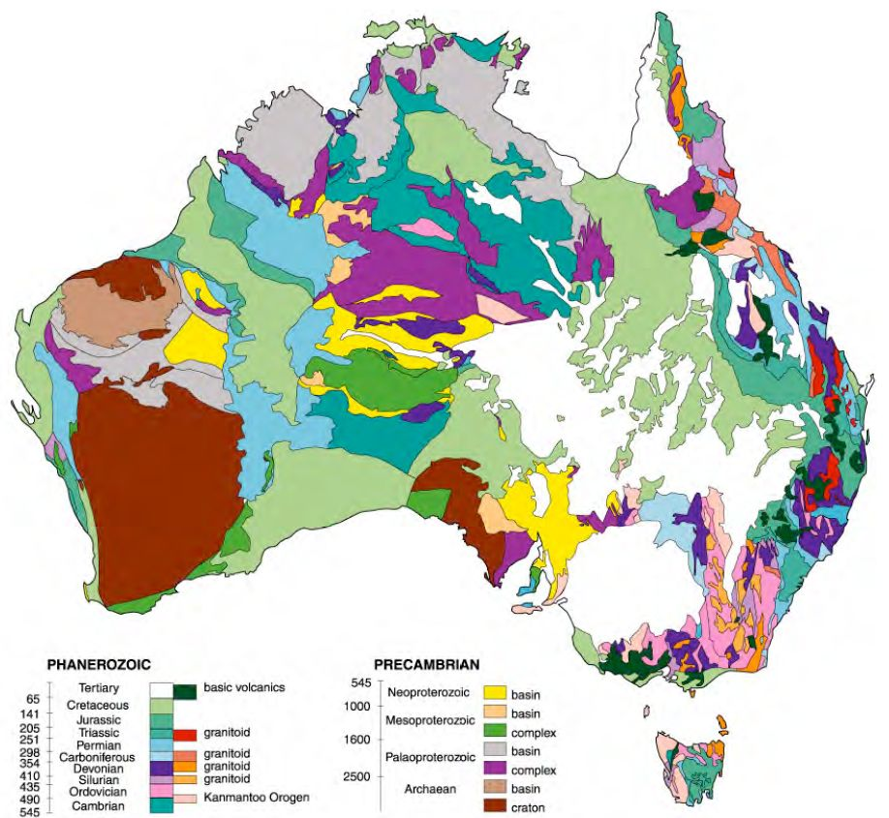

**Sedimentary**

**Igneous**

**Metamorphic (Quartzite)**

**Sedimentary**

**Igneous (Basalt)**

**Metamorphic (Quartzite)**

**Igneous (Basalt)**

Basic Geological Map

*Australia*

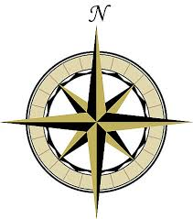

**Key**